TECHNOLOGY RELIABILITY RISK
Core Risk and Problem Statement, SWOT Linkage, Indicators, Thresholds and Controls

ALY6130: Risk Management for Analytics
Student Name: Musa Oseni Oyakhire
Master of Professional Studies in Analytics, Northeastern University
June 2026

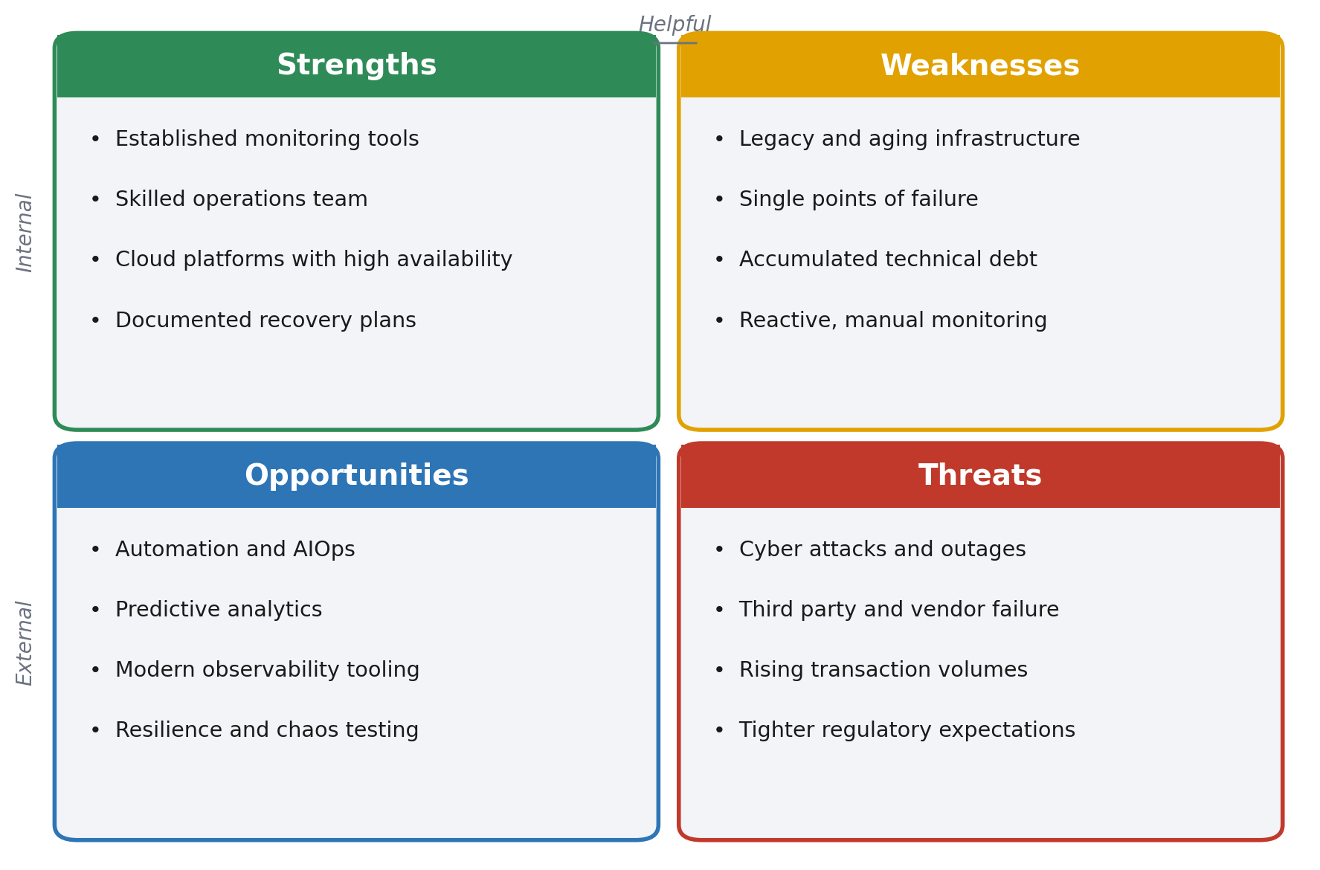

Contents
Contents 2
1. Executive Summary 3
2. Core Risk Statement…………………………………………………………………………………..3
3. Problem Statement…………………………………………………………………………..………..3
4. Risk Type Classification………………………………………………………………………………4
5. SWOT Analysis and Connection Summary………………………………………………………...5
Connection summary…………………………………………………………………………………….5
6. Key Risk Indicators………………………………………………………………………………….…5
7. Traffic Light Thresholds…………………………………………………………………………….…7
8. Controls…………………………………………………………………………………………………8
9. Monitoring, Escalation and Reporting……………………………………………………………….8
10. Conclusion…………………………………………………………………………………..………..9
References……………………………………………………………………………………………....10

1. Executive Summary
Technology reliability risk is the risk that critical systems, infrastructure and services fail to perform consistently and dependably, leading to outages, degraded performance and the unavailability of data and services on which the business and its customers depend. As the organisation deepens its reliance on complex and interconnected technology, the consequences of unreliable platforms grow in severity, spanning operational disruption, financial loss, regulatory breach and reputational damage.
This assessment sets out the core risk and problem statement, classifies the risk, summarises the connection to the SWOT analysis, and defines the key risk indicators, traffic light thresholds and controls used to manage the exposure. Reliability is treated here as a dimension of operational risk and is aligned with established guidance on the sound management of operational risk and on the disruption and system failure event category (Basel Committee on Banking Supervision, 2011).
The overall conclusion is that residual reliability risk is currently elevated. Internal weaknesses such as legacy infrastructure and single points of failure are the primary drivers, while external threats amplify the exposure. The control base is sound but partly reactive, and the highlighted indicators show one red and several amber readings that warrant management attention and an investment roadmap.

2. Core Risk Statement
Core risk statement
There is a risk that critical technology systems and infrastructure fail to deliver reliable, available and consistent service, resulting in operational disruption, financial loss, regulatory breach and reputational harm.

The statement captures both the cause, which is the failure of technology to perform dependably, and the effect, which is the chain of business consequences that follow. Reliability covers availability (the service is up when needed), performance (the service responds within acceptable limits) and recoverability (the service is restored quickly when it does fail). A weakness in any of these dimensions materialises the same underlying risk.

3. Problem Statement
The organisation depends on a large and growing estate of applications, platforms and infrastructure that must operate continuously to support customers, employees and regulated processes. Several structural conditions raise the likelihood and impact of reliability failures:
- Ageing and legacy infrastructure that is costly to maintain and increasingly difficult to support.
- Single points of failure and limited redundancy across parts of the estate, so that one component failure can cascade into a wider outage.
- Capacity constraints driven by rising transaction volumes that push systems beyond their designed limits at peak.
- Change related instability, where a meaningful share of incidents originate from changes that were poorly tested or released.
- Monitoring that is largely reactive, so that problems are often detected by customers rather than by the organisation.
- Concentration on a small number of third party and cloud providers, which transfers part of the reliability exposure outside direct control.
In combination these conditions mean that outages are not rare or purely random events but the predictable outcome of known weaknesses. The problem this assessment addresses is how to measure, threshold and control technology reliability so that the exposure is reduced to within risk appetite and managed proactively rather than after the fact.

4. Risk Type Classification
Technology reliability risk is classified as a non financial, operational risk. It is most closely aligned with the business disruption and system failure event category and sits within the wider technology and information risk taxonomy.
Classification dimension | Assessment
Primary category | Operational risk (non financial)
Sub category | Technology and information risk
Event type | Business disruption and system failures
Risk nature | Largely internal cause with external amplifiers
Velocity | High. Impact can be immediate once a failure occurs
Manageability | Controllable through architecture, monitoring and change discipline
Appetite | Low. The organisation seeks high availability of critical services

Classifying the risk in this way allows it to be reported within the operational risk framework, mapped to recognised control libraries and aggregated with other operational exposures for governance and capital purposes (ISACA, 2019).

5. SWOT Analysis and Connection Summary
The SWOT analysis below links the internal and external factors that shape technology reliability risk. Strengths and opportunities reduce the exposure, while weaknesses and threats increase it.

Figure 1. SWOT analysis mapped to technology reliability risk.

Connection summary
The four quadrants connect directly to the risk in a cause and control structure. Internal weaknesses, in particular legacy infrastructure and single points of failure, are the primary drivers that raise the likelihood and impact of reliability failures. External threats such as cyber attacks, third party failure and rising volumes act as amplifiers that can trigger or worsen those failures. Strengths form the existing control base, providing the monitoring, skills and recovery capability that limit the consequences when incidents occur. Opportunities define the treatment roadmap, since automation, predictive analytics and modern observability are the means by which weaknesses are reduced and resilience is improved over time.
Read together, the SWOT tells a clear story. The organisation has a capable foundation, but unless the weaknesses are addressed through the available opportunities, the external threats will continue to expose the same internal fault lines, and residual reliability risk will remain above appetite.

6. Key Risk Indicators
Key risk indicators provide an early and measurable signal of changes in the exposure. The indicators below cover availability, recovery, stability and capacity, which together describe the reliability of the estate.
Key risk indicator | What it measures | Why it matters
System availability | Percentage of time critical services are available | Direct measure of reliability against service commitments
Mean time to recovery | Average time to restore service after an incident | Shows how quickly the organisation recovers from failure
Priority 1 incidents | Count of critical incidents per month | Indicates frequency of severe reliability events
Change failure rate | Share of changes that cause an incident or rollback | Links instability to weak change management
Capacity utilisation | Peak use of compute, storage and network | Warns of failures driven by demand exceeding capacity
Backup success rate | Share of scheduled backups completing successfully | Underpins recoverability and data availability

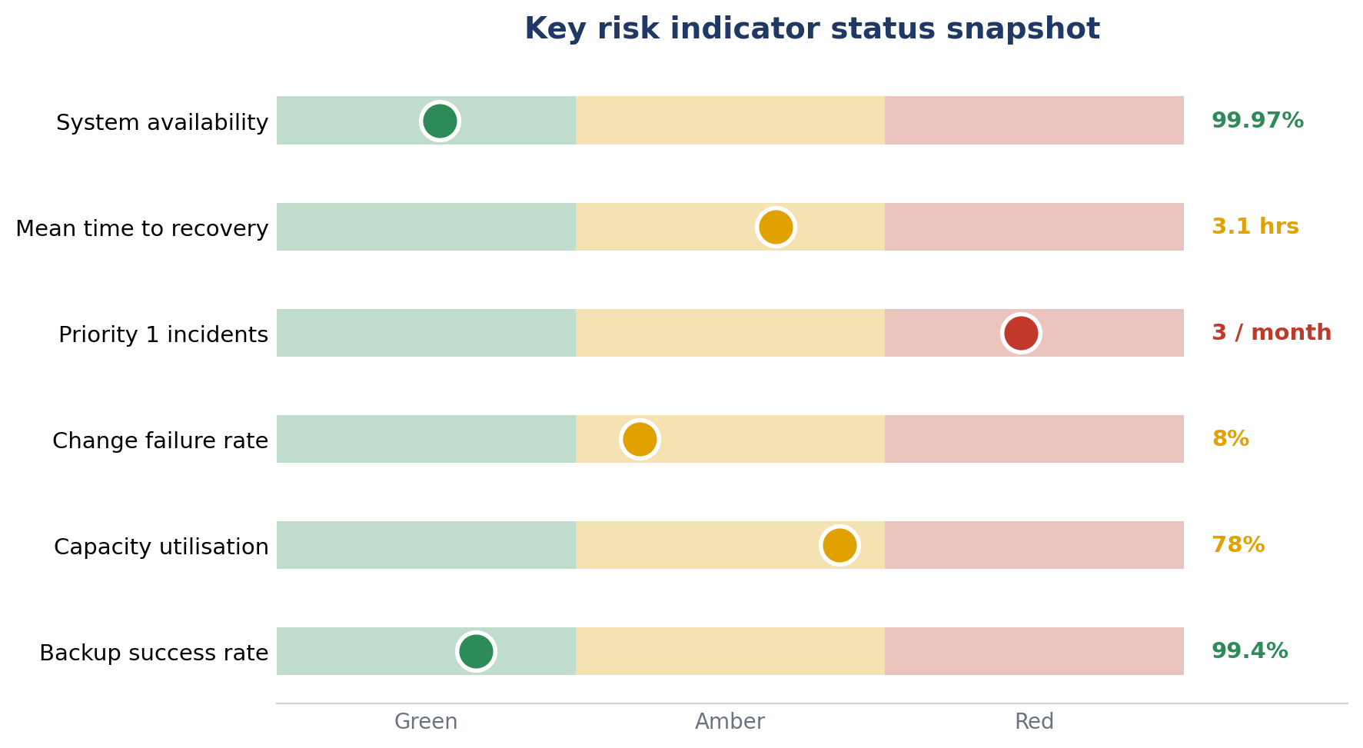
Figure 2. Current status of each key risk indicator on a green to red scale.
The current snapshot shows priority 1 incidents in red and recovery time, change failure rate and capacity utilisation in amber. Availability and backup success remain green. The pattern is consistent with the problem statement, pointing to instability and capacity pressure rather than a single isolated fault.

7. Traffic Light Thresholds
Each indicator is governed by traffic light thresholds. Green is within appetite, amber is a warning that requires review and a remediation plan, and red is a breach that requires escalation and management action.
Indicator | Green | Amber | Red | Red action
System availability | ≥ 99.95% | 99.5 to 99.95% | < 99.5% | Escalate to head of technology
Mean time to recovery | ≤ 2 hrs | 2 to 4 hrs | > 4 hrs | Invoke major incident review
Priority 1 incidents | 0 per month | 1 to 2 | ≥ 3 | Root cause and board reporting
Change failure rate | ≤ 5% | 5 to 10% | > 10% | Freeze non urgent changes
Capacity utilisation | ≤ 70% | 70 to 85% | > 85% | Approve capacity uplift
Backup success rate | ≥ 99% | 95 to 99% | < 95% | Remediate backup failures

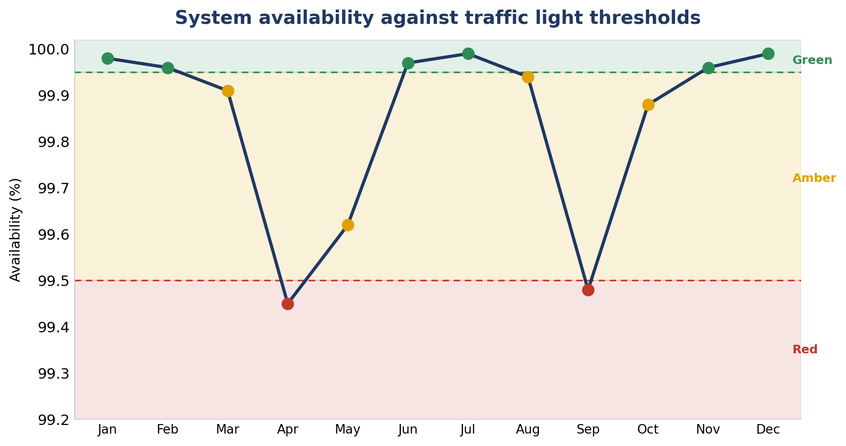
Figure 3. Twelve month availability trend with green, amber and red threshold bands.
The trend shows availability breaching the red threshold twice during the year, in both cases linked to outages on parts of the legacy estate. These breaches drive the elevated residual rating and reinforce the case for the remediation set out below.

8. Controls
Controls are grouped as preventive, detective and corrective. Preventive controls reduce the likelihood of failure, detective controls identify problems early, and corrective controls limit the impact and restore service quickly.
Type | Control | Risk addressed
Preventive | Resilient architecture with redundancy and high availability across critical services | Single points of failure and outages
Preventive | Capacity and demand management with forward looking forecasting | Failures driven by demand exceeding capacity
Preventive | Disciplined change management with testing, approval and release control | Change related instability
Preventive | Lifecycle and patch management to retire end of life assets | Ageing and unsupported infrastructure
Detective | Real time monitoring, alerting and indicator dashboards | Late detection of degradation and outages
Detective | Synthetic transaction monitoring and periodic recovery testing | Undetected service and recovery failures
Corrective | Major incident management with defined roles and escalation | Slow or disorganised response to failure
Corrective | Automated failover and tested rollback procedures | Prolonged downtime during an incident
Corrective | Root cause and problem management to prevent recurrence | Repeat incidents from the same cause

The control set draws on recognised service management and risk guidance, including frameworks for change, incident and problem management and for the governance of enterprise technology (AXELOS, 2019; ISACA, 2019). The priority gap is the shift from reactive to predictive monitoring, which is the opportunity most able to reduce residual risk.

9. Monitoring, Escalation and Reporting
Indicators are measured monthly, with critical availability metrics monitored continuously. Amber readings require a documented remediation plan with an owner and a target date. Red readings are escalated to senior technology management and, where appetite is breached, reported to the relevant risk committee. The approach follows a structured cycle of identification, assessment, treatment and monitoring consistent with established risk management guidance (Hopkin, 2018; International Organization for Standardization, 2018; National Institute of Standards and Technology, 2012).

10. Conclusion
Technology reliability risk is a material operational exposure that is driven mainly by internal weaknesses and amplified by external threats. The indicators and thresholds in this assessment make the exposure measurable, and the control set provides a sound foundation. Residual risk is currently elevated, evidenced by recurring critical incidents and threshold breaches. Reducing it depends on executing the opportunities identified in the SWOT, in particular the move to predictive monitoring, the removal of single points of failure and the modernisation of the legacy estate.

References
AXELOS. (2019). ITIL foundation: ITIL 4 edition. The Stationery Office.
Basel Committee on Banking Supervision. (2011). Principles for the sound management of operational risk. Bank for International Settlements.
Hopkin, P. (2018). Fundamentals of risk management: Understanding, evaluating and implementing effective risk management (5th ed.). Kogan Page.
International Organization for Standardization. (2018). ISO 31000:2018 risk management: Guidelines. ISO.
ISACA. (2019). COBIT 2019 framework: Governance and management objectives. ISACA.
National Institute of Standards and Technology. (2012). Guide for conducting risk assessments (Special Publication 800.30, Revision 1). U.S. Department of Commerce.

